https://www.jdoodle.com/embed/v0/5PRv
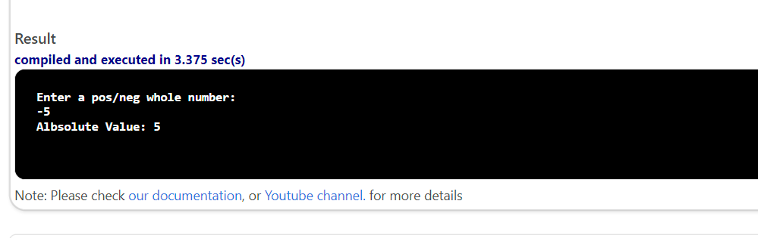
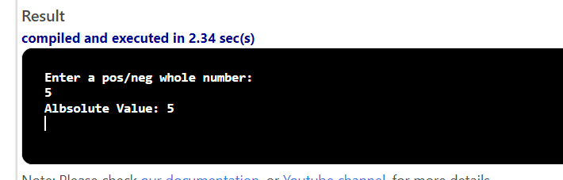

#include <iostream>

using namespace std;

int main()
{
int n;
cout << "Enter a pos/neg whole number:"<< endl;
cin >> n;
if (n < 0)
{
n = (-1) * n;
}
cout << "Albsolute Value: "<< n << endl;
return 0;
}

